From the Events Director

It’s been a hectic and exciting year in the Events portfolio. I do hope that you have attended and enjoyed the events that we have put on for you this year. We have held five breakfast and seven chapter events, with approximately 900 members and guests attending. Topics have ranged from career management, personal branding and other soft skill development through the more ‘technical’ areas of enterprise change management, risk management and programme management. Of course, we cannot forget the war against the ‘zombies’ of project management.

Our chapter has some wonderful sponsors and the Events portfolio is very pleased to have DDLS sponsoring our Breakfast events. My thanks to Cheryl Moore, Melissa McLachlan and all the DDLS team for their commitment, support and great help at each Breakfast event. You can see other aspects of their commitment to PMI Sydney elsewhere in this newsletter and on the chapter website.

If you have been to an evening chapter event this year, you will probably have been impressed by the amazing dining room at The Castlereagh Boutique Hotel. My thanks to Rita, Guy and the team for all their help and support during the year as well.

For all of the above, none of this would be worthwhile if you, our members, did not turn up to the meetings. Thank you for your commitment to being there, especially on those cold and wet winter mornings. Your being there brings a deep satisfaction to the team and keeps our energy levels high throughout the year.

For 2014 we are looking to have a ‘bumper’ year with a packed calendar of events. Keep your eyes on the chapter website and don’t miss out when the events start again in February!

Finally, PMI is built on the work of volunteers and the Events portfolio is no exception. I would like to thank the wonderful team of volunteers who make it possible to organise and run the Breakfast and Evening Chapter events for our members and guests. You will see them at the reception desk at each event, but they do a lot more behind the scenes to ensure that everyone can enjoy the presentation, refreshments and networking opportunities. Thank you for everything you have done for our members and I, it is very much appreciated.

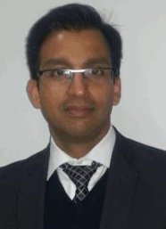 |  |  | 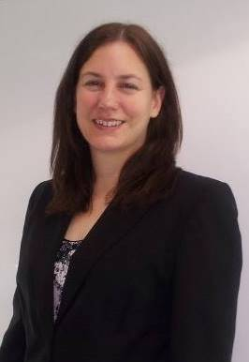
Saheel Hafiz | Tim Kinchington | Deepa Patole | Emma Stewart

PDUs
Remember, you are entitled to claim 1 PDU for every PMI Sydney Chapter event that you attend. Details of how to claim your PDUs as per the new categories are on our website via the ‘Professional Development’ tab and the ‘Claiming PDUs’ option.

